|  |
| --- |
| Mapa del sitio |
|  |

01. Mapa del sitio / Prototype1_EMP

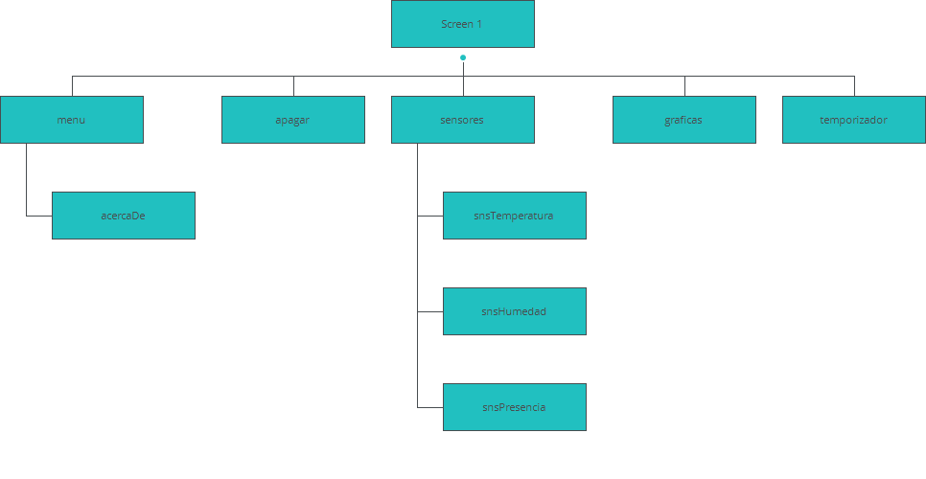

|  |
| --- |
| Pantallazos |
|  |

02. Pantallazos / Prototype1_EMP

Index

|  |
| --- |
|  |

Interacción

|  |  |
| --- | --- |
| 1 | **on Click:** ir a 'menu' 🡪 |
| 2 | **on Click:** ir a 'apagar' 🡪 |
| 3 | **on Click:** ir a 'sensores' 🡪 |
| 4 | **on Click:** ir a 'graficas' 🡪 |
| 5 | **on Click:** ir a 'temporizador' 🡪 |

02. Pantallazos / Prototype1_EMP

menu

|  |
| --- |
|  |

Interacción

|  |  |
| --- | --- |
| 6 | **on Click:** Ir a Index' 🡪 |
| 7 | **on Click:** Ir a 'apagar' 🡪 |
| 8 | **on Click:** Ir a 'sensores' 🡪 |
| 9 | **on Click:** Ir a 'graficas' 🡪 |
| 10 | **on Click:** Ir a 'temporizador' 🡪 |
| 11 | **on Click:** Ir a 'acercaDe' 🡪 |

02. Pantallazo / Prototype1_EMP

apagar

|  |
| --- |
|  |

Interaccion

|  |  |
| --- | --- |
| 12 | **on Click:** Ir a 'menu' 🡪 |
| 13 | **on Click:** Ir a ‘Index' 🡪 |

02. Pantallazo / Prototype1_EMP

sensores

|  |
| --- |
|  |

Interaccion

|  |  |
| --- | --- |
| 14 | **on Click:** Ir a 'menu' 🡪 |
| 15 | **on Click:** Ir a 'snsTemperatura' 🡪 |
| 16 | **on Click:** Ir a 'snsHumedad' 🡪 |
| 17 | **on Click:** Ir a 'snsPresencia' 🡪 |
| 18 | **on Click:** Ir a ‘Index' 🡪 |

02. Pantallazo / Prototype1_EMP

graficas

|  |
| --- |
|  |

Interacción

|  |  |
| --- | --- |
| 19 | **on Click:** Ir a 'menu' 🡪 |
| 20 | **on Click:** Ir a 'Index' 🡪 |

02. Pantallazo / Prototype1_EMP

temporizador

|  |
| --- |
|  |

Interacción

|  |  |
| --- | --- |
| 21 | **on Click:** Ir a 'menu' 🡪 |
| 22 | **on Click:** Ir a 'Index' 🡪 |

02. Pantallazo / Prototype1_EMP 

acercaDe

|  |
| --- |
|  |

Interacción

|  |  |
| --- | --- |
| 23 | **on Click:** Ir a 'menu' 🡪 |

02. Pantallazo / Prototype1_EMP

snsTemperatura

|  |
| --- |
|  |

Interacción

|  |  |
| --- | --- |
| 24 | **on Click:** Ir a 'sensores' 🡪 |

02. Pantallazo / Prototype1_EMP

snsHumedad

|  |
| --- |
|  |

Interacción

|  |  |
| --- | --- |
| 25 | **on Click:** Ir a 'sensores' 🡪 |

02. Pantallazo / Prototype1_EMP

snsPresencia

|  |
| --- |
|  |

Interacción

|  |  |
| --- | --- |
| 26 | **on Click:** Ir a 'sensores' 🡪 |